**job_costsheet_import**

**1. The correct Format of the Excel file to be imported (column headers).**

**Answer =>**

1. **Column Project (Jobs / Projects / Projects) needs to be created before import as per sample xls file since the system searches project by name.**
2. **Column Analytic Account (Invoicing / Configuration / Analytic Accounting / Analytic Accounts) needs to be created before import as per the sample xls file since the system searches the analytic account by its name.**
3. **Column Job Order (project task) (Jobs / Job Orders / Job Orders) needs to be created before import as per the sample xls file since the system search job order by its name.**
4. **Column Customer (Sales / Orders / Customers) needs to be created before import as per the sample xls file since the system search customer by their name.**
5. **Column Date format needs to be ('%d/%m/%Y') so make sure your import file has to be in that format.**
6. **Column Job Type (Jobs / Configuration / Job Types) needs to be created before import as per sample xls file since the system search job type by name.**
7. **Column Product (Sales / Products / Products) needs to be created before import as per sample xls file since the system search product by its name.**

**Path of Sample File: *job_costsheet_import / sample / job_costsheet.xls***

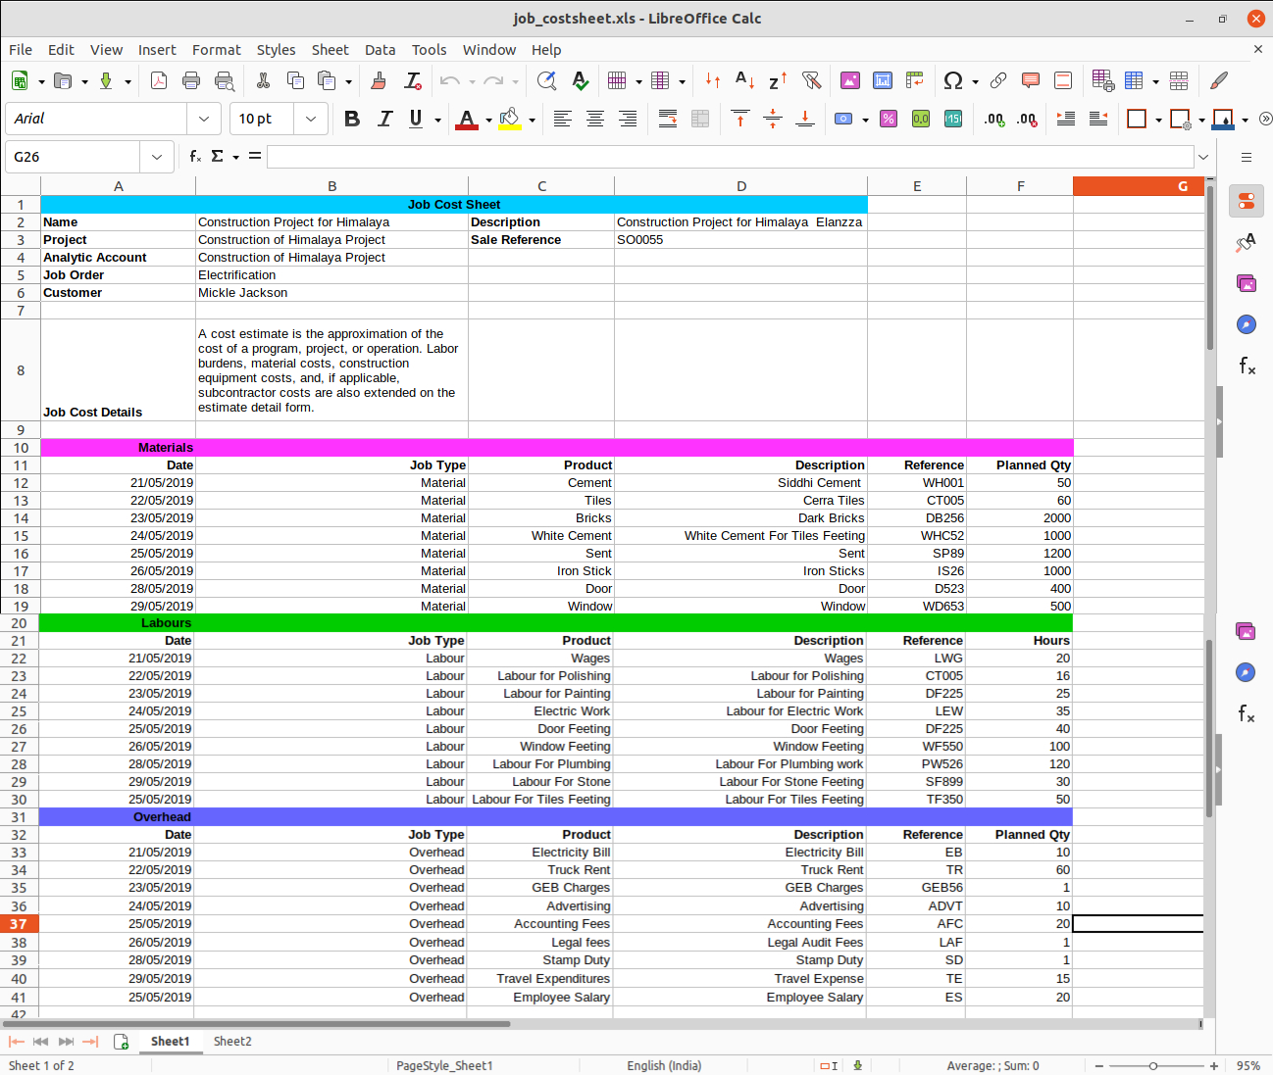

**THANK YOU**